**The National Institute of Engineering**

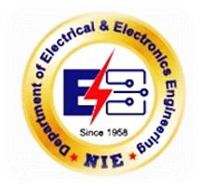

(An Autonomous Institution affiliated under

Visvesvaraya Technological University, Belagavi)

Manandawadi Road, Mysuru – 570008

**DIGITIZED MONEY TRANSACTIONS**

**“Contribution towards Digital India”**

*As a partial fulfillment for the award of Degree in Electrical & Electronics Engineering*

**A public service activity for the award of activity points organized by**

**Tahsildar, Mysuru, Government of Karnataka**

**Submitted by**

**A Madhukar – 4NI19EE001**

# Under the Guidance of

## Ms. Ashwini G

Assistant Professor

Department of Electrical & Electronics Engineering

NIE, Mysuru



## DEPARTMENT OF ELECTRICAL & ELECTRONICS ENGINEERING

The National Institute of Engineering

Manandawadi Road, Mysuru – 570008

# The National Institute of Engineering,Mysuru – 08



(An Autonomous Institution affiliated under

Visvesvaraya Technological University, Belagavi)

**Department of Electrical & Electronics Engineering**

# CERTIFICATE

This is to certify that the activity entitled **“DIGITIZED MONEY TRANSACTIONS”** is a bonafide work carried out by **A Madhukar** bearing **USN: 4NI19EE001,** student of **T h e** **National Institute of Engineering** inpartial fulfillment for the award of **Bachelor of Engineering** in **Electrical & Electronics Engineering** of the Visvesvaraya Technological University, Belagavi during the year 202223. It is certified that all theory/practical/corrections/suggestions indicated for Activity Points have been executed under the directions of **Ms. Ashwini G** Mam**.** The activity report has been approved as it satisfies the academic requirements regarding AICTE Activity Points prescribed for the degree.

## Ms. Ashwini G Dr. Pradeepa H

Assistant professor Head of the Department

Dept. of Electrical & Electronics Dept. of Electrical & Electronics

Engineering Engineering

The National Institute of Engineering The National Institute of Engineering

Mysuru-570008 Mysuru-570008

**Dr. Rohini Nagapadma, Ph.D.**

The National Institute of Engineering Mysuru - 570 008

|  |  |
| --- | --- |
| A MADHUKAR (4NI19EE001) |  |

# DECLARATION

I, **A Madhukar,** bearing **USN: 4NI19EE001**, student of VIII semester B.E., Department of Electrical & Electronics Engineering, **The** **National Institute of Engineering**, Mysuru declare that the AICTE Activity Project work entitled **“DIGITIZED MONEY TRANSACTIONS”**, has been duly executed by me, organized by Mysore City Corporation, under the guidance of Tahsildar, Mysuru and Ms. Ashwini G, Asst Professor, Department of Electrical & Electronics Engineering, **The** **National Institute of Engineering**, **Mysuru**. The Activity report of the same is submitted in partial fulfillment of the requirement for the award of a Bachelor of Engineering degree in the Department of Electrical & Electronics Engineering by Visvesvaraya Technological University, Belagavi during the year 2022- 2023.

**Date:**

## Place: Mysuru Signature of Student

# ACKNOWLEDGEMENT

The satisfaction that accompanies the successful completion of the project report which would be complete only with the people who made it possible, whose report rewarded the effort with success of AICTE Activity.

We are grateful to **The** **National Institute of Engineering** for giving us an opportunity to enhance our knowledge through the activity.

We express our sincere thanks to **Dr. Rohini Nagapadma**, Principal, NIE, Mysuru for providing us an opportunity and means to present the activity.

We express our heart full thanks to **Dr. Pradeepa H,** Associate Professor and Head, Department of Electrical & Electronics Engineering, NIE, Mysuru for encouragement in our project work, whose cooperation and guidance helped in nurturing this project report.

We would like to express profound thanks to the activity guide **Ms. Ashwini G, Asst Professor**,

Department of Electrical & Electronics Engineering for her keen interest and encouragement in our AICTE Activity.

We are grateful for **Mysuru City Corporation** for providing us with this opportunity. We extend our thanks to the **Tahsildar, Mysuru** for their effort and endurance to bring out the best in us.

Finally, we would like to thank our family members and friends for standing with us through all times.

|  |  |
| --- | --- |
| 1.  2.  3.  4.  5. 6. | **TABLE OF CONTENTS**      **ABSTRACT ..........................................................................................................................2**  **NECESSITY OF AICTE ACTIVITY…………………………………………………….…3**  **INTRODUCTION ................................................................................................................5**  **BENEFITS OF DIGITAL INDIA……………………………………………………………………………………………**.**8**  **PHOTO GALLERY .............................................................................................................9**  **CONCLUSION ................................................................................................................... 10** |
|  | 1 | D e p a r t m e n t o f E l e c t r i c a l & E l e c t r o n i c s E n g i n e e r i n g |

# ABSTRACT

Digi Dhan Mission

The Digital India Programme envisions transforming India into a digitally empowered society and knowledge economy by making digital governance and services available to every citizen. Promotion of digital payments ecosystem is an essential aspect of Digital India programme and has the potential to transform Indian economy by extending inclusive financial services.

During the course of the projects, we have helped vendors, farmers and on various levels to help them get accustomed to digital transactions. We have made an effort to convince a part of elderly rural population to be part of Digi Dhan mission.

The Digital India Programme envisions transforming India into a digitally empowered society and knowledge economy by making available digital governance and digital services to every citizen. Promotion of digital payments ecosystem is an essential aspect of Digital India programme and has the potential to transform Indian economy by extending inclusive financial services.

The Government of India in the Union Budget for 2017-18, announced the setting up of a Mission for promotion of digital payments with a target of 2,500 crore digital transactions during the financial year through UPI, USSD, Aadhaar Pay, IMPS and Debit cards.

The project aims to create awareness towards building a society who do not fear digital transactions. To urge people to use safe and secure online payment apps.

# NECESSITY OF THE AICTE ACVITITY POINTS

AICTE Council has mandated all the 4-year Technical Degree Enrolled students to Earn 100/75/50/25 Activity Points as per the Instructions.

Today, India has seen enormous development in Urban Infrastructure. Except for the pollution and increased expenses for lifestyle, Urban India has all basic infrastructures such as Education, Health, Transport, Employment, Food, and Special Services at reachable levels.

At the same time, Rural India has not seen any development in the accessibility of basic infrastructures. They have to travel a long distance to access even a small basic infrastructure. Though pollution and expenses for lifestyle is very less in Rural Areas, people are migrating to the Urban areas as they need Basic Infrastructure than the other facilities available in Rural India As per the experts, if at all Urban India has seen enormous development it is due to the

* Engineering Solutions 
* Engineering Implementations 
* Engineering Employments Though engineering contribution is more in the development there are other segments that contributed to the sustainable Urban Infrastructure such as 
* Health 
* Education 
* Transport 
* Dwelling Places  • Government Policies 

This is a motivational concept by AICTE to bring Social Innovation in Engineers at their education level to

* Address the Social Challenges of India 
* Propose a practical solution to such challenges 
* Bring more Social Innovations and Research 
* Blend the available technology for effective solutions AICTE Activity Points is very essential in shaping India for the sustainable life style 

**INTRODUCTION**

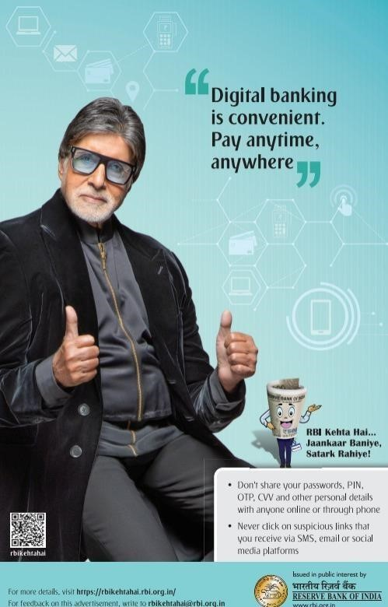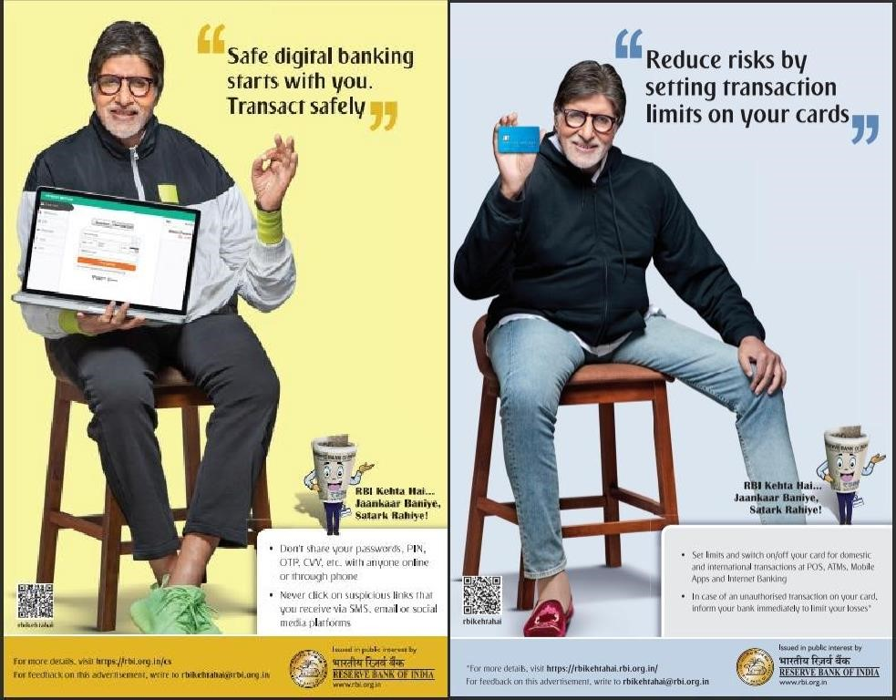

The “Digital India” campaign was launched by the government of India to uplift the usage of technology in India. The objective was to make Government services easily available to the citizens electronically by improving its online infrastructure all over the country. The process would be structured to increase internet connectivity to make the country digitally empowered. It helps to reach out to the masses and encourages them to use technology in their daily lives. Prime Minister Mr. Narendra Modi launched the campaign on July 1, 2015. The initiative aims at connecting rural India with the help of high-speed internet connectivity.

There are three components at the core of the “Digital India” campaign.

## • Creation of Digital Infrastructure

To be able to deploy various digital services across the country, it is necessary to create a strong digital infrastructure, especially in rural areas of the country. The interior regions of the country either have very little or mostly do not have any electronic network. This is the reason behind establishing a digital network across the country. Bharat Broadband Network Limited, the governmental body that is responsible for the execution of the National Optical Fiber Network project is responsible for the Digital India project as well. Bharat Net aims to connect 2,50,500 gram panchayats across the country to a high-speed internet network via an optical fiber network. 4,00,000 internet points will be established all across the country as part of the program, from which anybody will be able to access the internet.

## • Digital Literacy

For full participation of the people of India, the competency that they need to have is called Digital Literacy. The basic behavior, knowledge, and skills required to effectively use digital devices are mandatory. Desktop PCs, laptops, tablets, and smartphones are the digital devices used for the purpose of communicating, expressing, collaborating, and advocating. The mission of Digital Literacy will be covering over six crore rural households.

With the Digital India Programme, the Government of India is hoping to achieve all-around growth on multiple fronts collectively. The objective of the Government is to target the nine ‘Pillars of Digital India’ that are identified as follows.

* Broadband Highways
* Universal Access to Mobile Connectivity o Public Interest Access Programme o E-Governance
* E-Kranti o Global Information o Electronics Manufacturing o Training in Information Technology for Jobs o Early Harvest Programmes

The awareness of the importance of technology has been successfully created among the masses of India by the Digital India campaign. There has been a vast growth in the usage of the internet and technology in the past few years. The Panchkula district in Haryana was awarded the best and top performing district under the Digital India campaign on the 28th of December 2015.

So far, services such as digital lockers, my government website, e-education, scholarships, pensions, ration cards, PAN cards, Aadhar cards, e-insurance, and e-health have been made accessible under this plan. The goal has been established for the Digital India project to be completely implemented by 2019.

Technology giants from all over the world paid attention to the Digital India campaign and are readily and happily supporting the initiative. Even Mark Zuckerberg, the CEO of Facebook, had changed his profile picture to support Digital India. He started a trend on Facebook and promised to get the WiFi Hotspots in rural India working. Google started on its commitment to providing broadband connectivity at 500 railway stations in India. Microsoft agreed on providing broadband connectivity to 5,00,000 villages in the country. Microsoft is also making India its cloud hub via the Indian data centers. Oracle planned on investing in 20 states to work on Smart City initiatives and payments.

Some of the digital frameworks that are established under this scheme are given here:

* **Accessible India Campaign and Mobile App** - It is also known as Sugamya Bharat Abhiyan. Its principal goal is to make all services open to individuals with disabilities.
* **Mygov.in** - This forum allows users to voice their thoughts on the government's administration strategy. It has been implemented so that locals may actively participate.
* **Unified Mobile Application for New-age Governance (UMANG)** - This mobile platform can be used on any device. This software is available in a variety of Indian languages. This software allows users to access a variety of services. Education portals, a digital locker, Aadhar, tax, and train ticket purchasing are among the services available.
* **Agri market App** - It was created to make agricultural prices known to farmers and discourage them from selling too soon.

|  |  |
| --- | --- |
| •  •  •  •  •  •  • | **Beti Bachao Beti Padhao**- Ensuring the welfare and nurturing of a girl child and also making sure that every girl child attends school.  **Bharat Interface for Money (BHIM)**- It makes payments quickly, easily, and simply through the Unified Payment Interface (UPI). It also allows the bank to accept instant payments and money collections using mobile phone numbers.  **Crop Insurance Mobile App**- Used to calculate crop insurance premiums depending on numerous characteristics such as area or loan amount, if a loan is taken out.  **E-Hospital**- It's an HMIS (Hospital Management Information System) for hospitals' internal workflows and operations.  **E-Pathshala**- The National Council of Educational Research and Training (NCERT) created it to make all educational resources, such as books and videos, available online.  **EPFO Web Portal and Mobile App**- Allow workers to check the amount of their provident fund using an e-passbook, which is a virtual equivalent of a real passbook.  **Start-up India Portal and Mobile App**- It is a government of India program to encourage entrepreneurs to develop businesses (start-ups) in the country to expand sustainably. |
|  | 7 | D e p a r t m e n t o f E l e c t r i c a l & E l e c t r o n i c s E n g i n e e r i n g |

## Benefits of Digital India

* It makes health care and literacy more accessible since one may use a hospital service to receive online registration, a doctor's appointment, payment of the charge, a diagnostic test, and a blood test, among other things.
* It allows consumers to submit their paperwork and certifications online from anywhere, reducing the amount of physical work required.
* Citizens can digitally sign their records online to sign the framework.
* It benefits the beneficiaries of the National Scholarship Portal by allowing them to submit applications, have them verified, and then be paid or disbursed.
* BSNL's next-generation network will replace 30-year-old telephone exchanges for improved administration of online services on mobile devices like voice, data, multimedia, etc.
* Flexible electronics will be promoted with the support of the National Center for Flexible Electronics.
* As all transactions are completed through the digital method, it also aids in the reduction of black marketing.

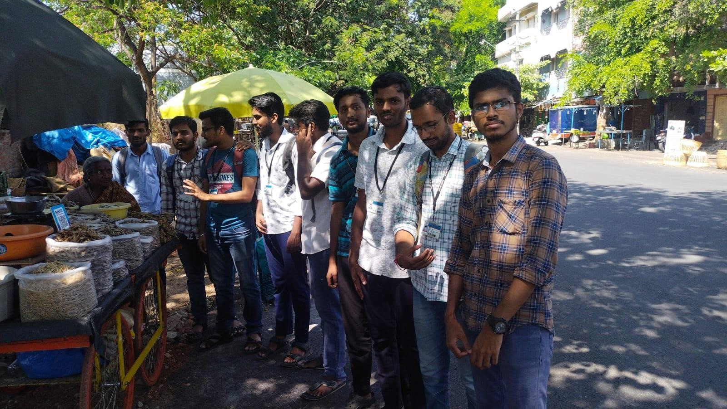

Volunteers for Digitized Money Transactions Activity

**PHOTO**

**GALLERY**

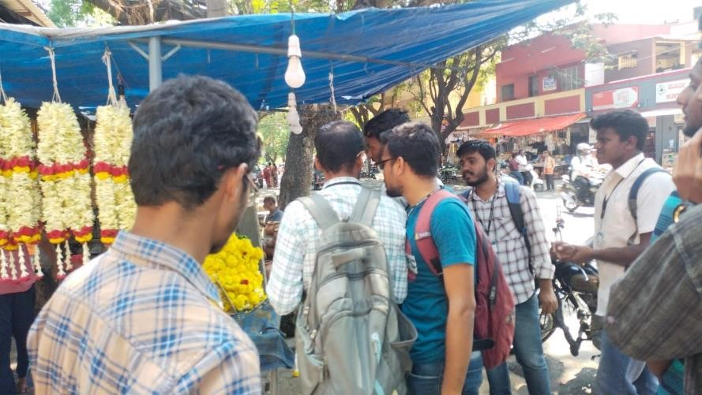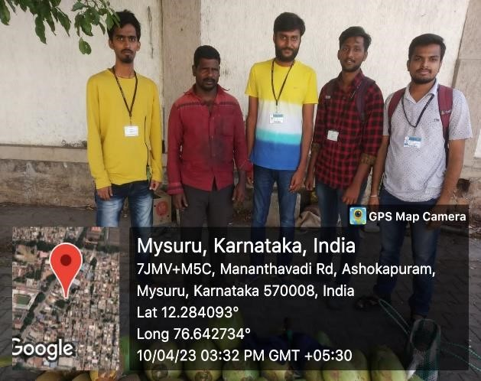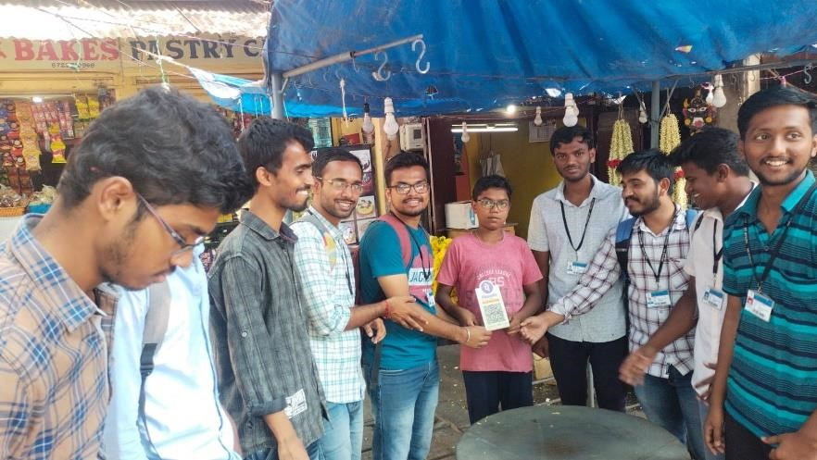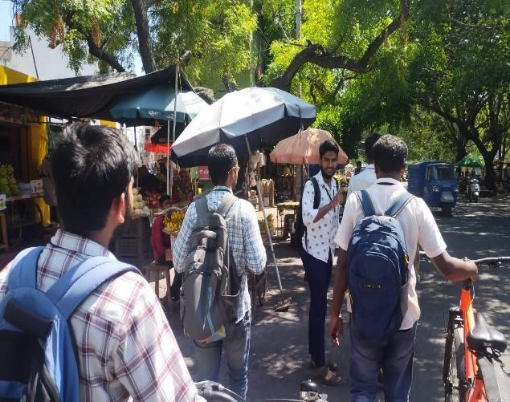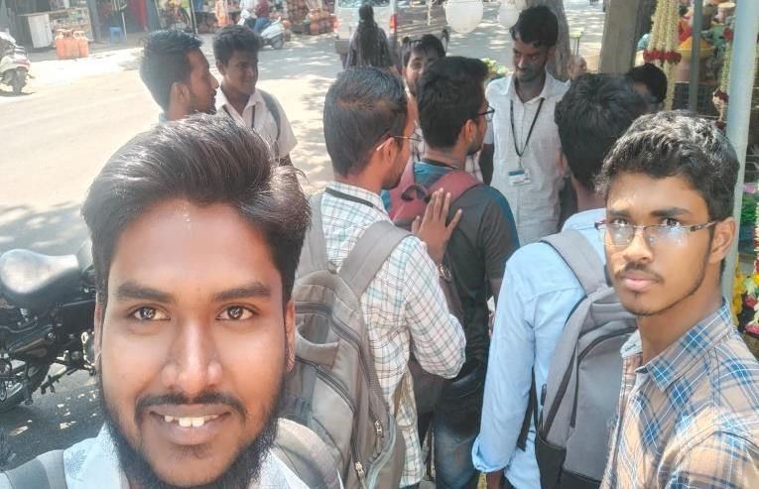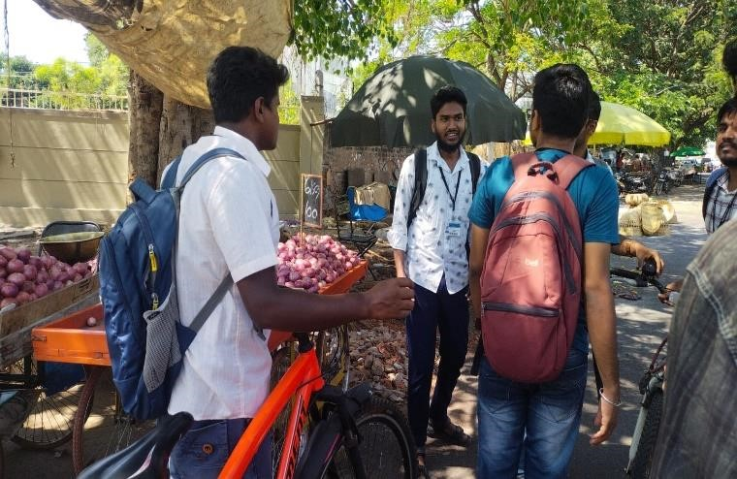

# CONCLUSION

We wish to conclude by highlighting the fact that this project has made its impact by organizing and creating awareness about government of India efforts for making digitized transactions. The privileges highlighted are as follows

* **Exemption from payment of service charge** on booking of E Ticket up to 30th September 2017.
* Exemption of INR 30 service charge for all journey tickets booked from UTS counters. Applicable for all tickets booked through the usage of debit and credit cards.
* Withdrawal of INR 30 service charge to be applicable on transactions against creditand debit cards for the purchase of tickets at PRS counters.
* Extension of free-of-cost travel insurance up to 30.09.17 for confirmed/RAC railway passengers who buy their journey tickets from IRCTC.
* Online discount of 5% on online/digital booking of retiring rooms wef from 1st January ’17.
* Provision of 0.5% discount on booking of seasonal suburban tickets through digital means extended up to 30.09.17.
* Extension of 5% discount on payment for booking of paid catering services extended up to 30.09.17.